Digitization in Teaching and Learning: Opportunities and Challenges

Sachin Sakhare, Professor, Computer Engineering, Vishwakarma Institute of Information Technology, sachin.sakhare@viit.ac.in
Nidhi Santosh Kulkarni, Vishwakarma Institute of Information Technology, nidhi.21810100@viit.ac.in, Nidhi Deshpande, Vishwakarma Institute of Information Technology, nidhi.21810041@viit.ac.in,
Apurva Pingale, Vishwakarma Institute of Information Technology, apurva.21810611@viit.ac.in,
Computer Engineering Department, Vishwakarma Institute of Information Technology,
Pune, 411048

ABSTRACT:

Everyone was forced to stay at home and finish their work due to the COVID-19 outbreak. The educational system was severely impacted as a result of this. Teachers and students were both pushed to work in a digital environment. Both of them faced numerous problems, including internet troubles, software requirements for holding classes, and so on. Witnessing these difficulties, we decided to undertake a poll that takes into account a variety of factors such as the location of students and professors, internet connectivity, engagement in college work, online assessments, and so on. According to the responses, 1060 students from various departments such as Computer Engineering, Electronics and Telecommunications Engineering, Mechanical Engineering, Civil Engineering and others, as well as 180 teachers, took part in the survey. We were able to determine the relationship between the traits based on the results of our survey. It was clear that few students were interested in online learning, and there were a variety of reasons for this, including practical and teacher interactions. Those in rural locations have to deal with a lot more connectivity challenges than students in cities. This was also one of the explanations for students' lack of interest and engagement in online classes. Aside from that, it was clear that online exams were ripe for cheating. Despite the precautions implemented, several malpractices could be committed during online exams. We could figure out which instructional strategies engage students the most. It was clear that the pupils were focused on the teaching. We could also find out how many students receive the necessary work assistance. We could identify some solutions based on all of these insights to make online learning more engaging for both students and teachers. As a result, this research will undoubtedly aid better online learning both during and after the pandemic.

KEYWORDS:

Online, Pandemic, Covid-19, Virtual learning, Virtual Classroom, Teachers, Data Visualization

INTRODUCTION:

Distance learning, also known as online learning, is traditionally defined as an educational or learning procedure in which students are geographically separated. People are not completely unfamiliar with online learning. According to a study, online learning began in the 1960s at the University of Illinois. Due to the increasing importance of education in India, distance learning was introduced in 1962. There are currently platforms such as Coursera, EDX, and others that provide courses from various universities.
This has greatly benefited engineering students. Even though online education is not a new concept, the COVID 19 pandemic has created numerous challenges. Distance learning was once considered a luxury, but it is now regarded as a necessity.
From March 2020, the colleges and universities were online and there were mixed reactions about this system.
Now as online education is mandatory, not everyone has access to the internet or other requirements. Based on the places where the students and teachers live there are more internet issues. Also, there are different challenges department-wise. Engineering is not a theory-oriented subject, it requires a practical approach. Getting this practical knowledge is difficult from this online learning. Conducting practical for Mechanical department, Civil department, etc. online is not so fruitful. Computer Engineering, Information Technology departments are the most benefited from this. But others suffer a little due to a lack of practical orientation. Now there are various reasons for this including the software required, internet connection. Also, many students have their practical sessions by teachers sharing their screen or just by the PowerPoint presentation. Not only are these but there various other problems faced.

The main contribution of this study is:
- The preparation of a questionnaire for students and teachers for noting their experiences during this COVID-19 pandemic.
- Preparation of the data set that we got from the responses collected from the survey initiated for teachers and students.
- Graphs and visualization to draw useful inferences and interpretations from the data set.

PAPER ORGANISATION:

The next section of the chapter is organized as related work which includes the works related to the topic, the next section is of the proposed methodology where the working methods are discussed. The next section is of dataset and dataset description and the last section is of results and discussions.

RELATED WORK:

Since the COVID-19 outbreak in March 2020, it has caused havoc across the world this has brought far-reaching changes in all aspects of our lives and the education system has also been hit hard. Students, schools, colleges and universities have been strongly affected. During this pandemic many researchers have also shared their works on teaching and learning in different ways. Edwige Simon in his research employed a mixed method approach to investigate the impact of online teaching on higher education educators' professional identity, and the role played by technology in this process[1].The work by Shadnaz Asgari, Jelena Trajkovic, Mehran Rahmani, Wenlu Zhang, Roger C. Lo, Antonella Sciortino conducts a thorough (quantitative and qualitative) analysis of challenges and factors affecting the online education of engineering courses by conducting surveys among students and faculty members from various engineering subfields at one of the largest and most diverse four-year U.S universities (CSULB)[2]. Paul Gorsky and Ina Blau in their work discuss findings and conclusions concerning teaching effectiveness in traditional classrooms [3]. The work by Michał Bączek, Michalina Zagańczyk-Bączek, Monika Szpringer, Andrzej Jaroszyński, and Beata Wożakowska-Kapłon used the survey method and then drew conclusions based on the responses [4]. M.Sandeep Kumar, Prabhu Jayagopal, Shakeel Ahmed, S. S. Manivannan, Kiruba Thangam Raja, S. Sree Dharinya, gives us an overview of the adoption of e learning during Covid 19 in India[6]. Pinaki Chakraborty, Prabhat Mittal, Savita Yadav, through their work discuss about the students opinion about online education during the pandemic [17]. The work by Showkat Ahmad Dar, Ahmad Naseer discusses the importance of online learning and Strengths, Weaknesses, Opportunities, & Challenges (SWOC) analysis of e-learning modes in the time of crisis and also put some light on the growth of EdTech Start-ups during the time of pandemic and natural disasters and includes suggestions for academic institutions of how to deal with challenges associated with online learning [21]. The work by Elizabeth Armstrong-Mensah, Kim Ramsey-White, Barbara Yankey, Shannon Self-Brown had purpose of collecting information on how the transition to distance learning impacted undergraduate and graduate students taking courses in public health at GSU and the goal was to identify student academic challenges and unforeseen benefits of distance learning, and to use that information to inform practices that can be implemented during future crises that impact university education[22]. The paper by Amit Joshi, Muddu Vinay, and Preeti Bhaskar aims to identify the challenges faced by the teachers during online teaching and assessment in different home environment settings in India [20].The paper by Lokanath Mishra, Tushar Gupta, Abha Shree employs both quantitative and qualitative approach to study the perceptions of teachers and students on online teaching-learning modes and also highlighted the implementation process of online teaching-learning modes [15]. Many educational institutions that were earlier reluctant to change their traditional practices had no choice but to move to online teaching–learning. There is a strong need to innovate alternative educational systems and implement them. It offers how India adopts the e-learning approach in this situation. The outbreak also describes how to handle challenges related to online learning. Online learning and teaching needs only suitable internet connectivity and a laptop or smartphone. Also, students do not have to move from one place to another. Learning from home also provides a good and relaxing place to concentrate, as students can have the best surroundings for themselves. The importance of e-learning is rising, as the academic year has been completely disturbed due to COVID-19.
The chapter is organized as follows, the proposed methodology, dataset and data description, and results and discussions.

PROPOSED METHODOLOGY:

We have been witnessing these problems and this is what made our research on this topic, especially for engineering students and teachers, find out some solutions to ease the difficulties in online education.
To analyze the situation, we conducted a survey, for both teachers and students. Our work aims questions:

For Students:
- Is online education more conducive to cheating?
- At home/place of residence, how many responsibilities do you have?
- How difficult or easy is it for you to connect to the internet to access your work?
- How often do you get so focused on activities in your classes that you lose track of time?
- How difficult or easy is it to use online learning technology (computer, tablet, video calls, learning applications, etc.)
- Are you getting all the help you need with your work right now?
- If you are participating in distance learning, how often do you hear from your teachers individually?
- Which type of digital approach motivates you to learn?
- Are the online practical helpful?
- Do you have the software required for performing practical?
- How are practical conducted?
- How difficult or easy is it for you to try hard on your work right now?
- In your classes, how eager are you to participate?
- How much time do you spend on online lectures?
- What technology do you use to attend online classes?
- Department
For Teachers:
1. Do you have high-speed internet at home?
2. What device do you use for distance learning?
3. Which online teaching platform is used by your college?
4. Are you satisfied with the technology and software your university is using for online teaching?
5. How stressful do you find teaching remotely during the COVID-19 pandemic?
6. How well could you maintain a work-life balance while teaching remotely?
(Consider 5 being extremely well and 1 being not at all)
7. How stressful were your students while learning remotely during the COVID-19 pandemic?
(Consider 5 being extremely stressful and 1 being not at all)
8. How often do you have a 1-1 discussion with your students?
9. Are your students learning as much now as they were before switching to remote learning?
10. Which online assessment method is better?
11. How effective is an online assessment process? (Consider 5 being extremely well and 1 being not at all)
12. How much time do you spend each day on average on online teaching?
13. What kind of difficulties are you facing regarding the online practical concerning circuit/non-circuit branches?
14. How do you feel overall about online education?

The questions above almost cover all of the issues that students and teachers face. All of the important aspects of online classes, such as effectiveness, interest, access, student engagement, teacher involvement, and practical, could be gleaned from these questions. We were able to thoroughly investigate all of the issues and come up with a solution. The findings of this study could help to improve the efficacy of online learning.

DATASET AND DATA DESCRIPTION:

The goal of this study was to identify and investigate the magnitude of the impact of online teaching on both students and teachers. This survey was created using "Google Forms." There were other tools available, such as SurveyMonkey, but we chose Google Forms because it has no limit on the number of questions and is completely free. There were 16 multiple-choice questions in this survey. The questions were chosen so that they covered all of the important aspects of online teaching. The student survey included questions not only about technology, such as the software required or the technology used to attend online lectures (PC, Laptop, mobile phones) but also about student involvement. There are concerns about the teaching methods and the methods that students are interested in. This includes both theoretical and practical sessions. The questions about the online exams were also taken into account. The most pressing issue is that of cheating cases. With the general questions, we were also specific about the students' department and the area in which they live. These factors also have a significant impact on student participation in online learning.

To analyze the data we collected, we used the pivot tables. We used Excel and Power BI to create visualizations. From this we were able to get the exact number of students and teachers choosing options for every question. Also, we were able to get the percentages of each answer choice that was chosen.
By using the above method, we could get the correlation between the major aspects of students and also between students and teachers.

RESULTS AND DISCUSSION:

The survey was conducted using google forms.
A total of 1060 students participated in the survey.

6.1. Department
The students were from all the departments. About 36.8% of students were from the computer department, 23.6% of students were from the ENTC department, 21.7% were from the mechanical department, only 4.7% were from the civil department and 13.2% of students were from other departments like production engineering, industrial engineering, etc.

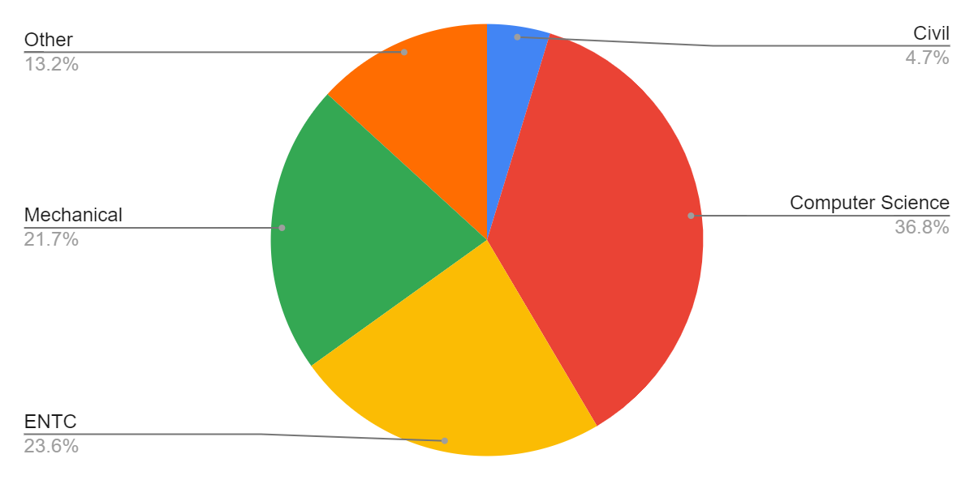

Fig 1
So numerically we can say that, out of 1060, 390 students were from the computer science department, 250 from ENTC, 230 from Mechanical, 140 from other departments, and only 50 students from the civil department.

6.2. Technology:

According to the survey 990 students out of 1060 students use mobile phones and laptops both for online classes, 30 students use phones, 20 students use PC, Laptops, and phones (all three of them), and 20 students use department screen shares. That is 93.4% of students use both laptops and phones for online classes.2.8% of students use phones (only) to attend classes.

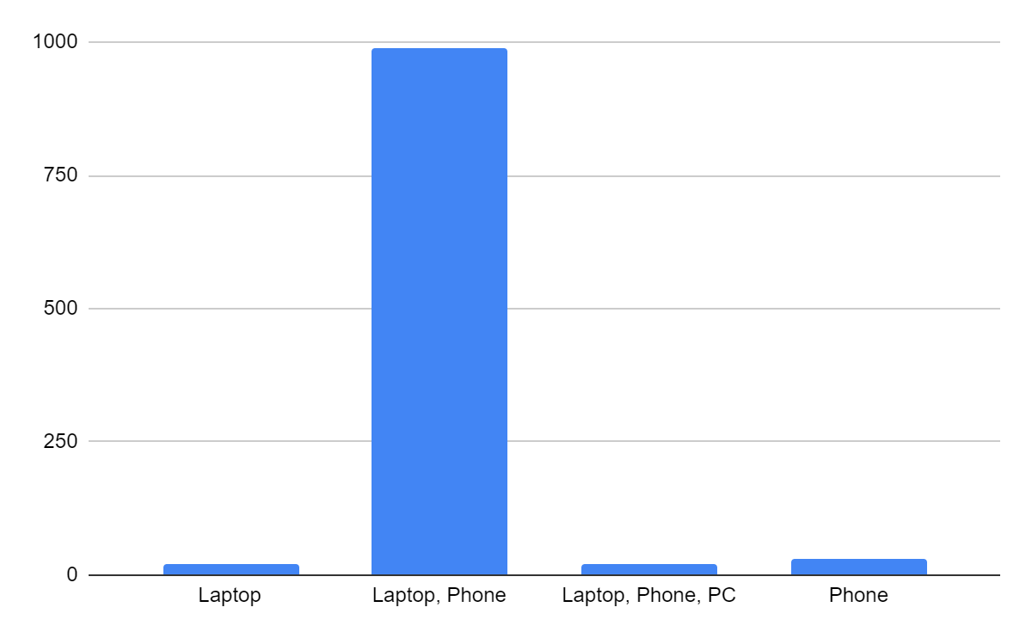
Fig 1.2

6.3. Participation:

36.8% of students are often interested in learning, 34% students show interest sometimes, 16 % students are always interested, 4.5% are rarely interested, and 8.5% (90/1060) students are never interested in learning.
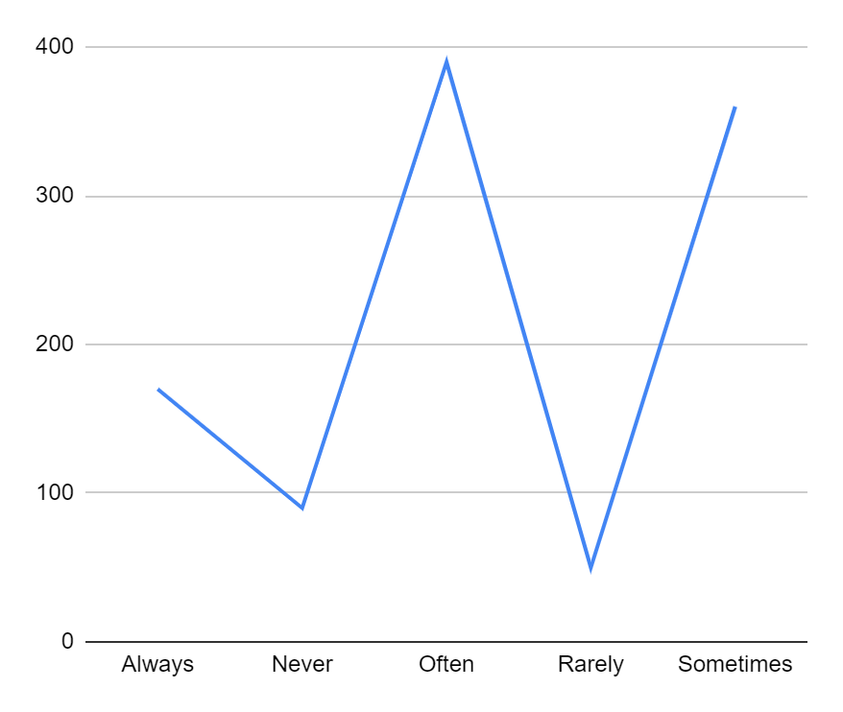
Fig 1.3

6.4 Time:
From the analysis we can see that 54.7% of students spend 3-5 hours, 21.7 % spend 1-3 and 5-7 hours, and only 1.9% of students spend 7-10 hours on online teaching.

6.5 Online Practical:
For most of the students i.e., 64.2%, online practical are conducted by screen share, 26.4% have their practical conducted by the applications.

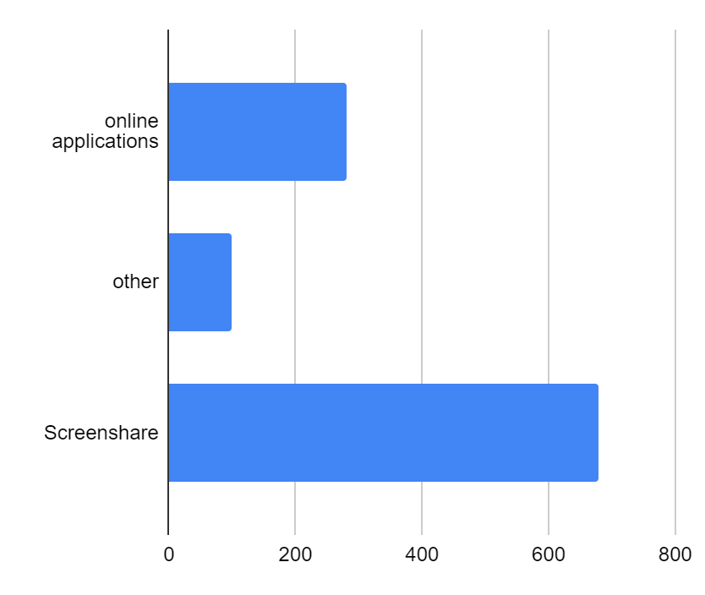
Fig 1.4

From the students whose practical are conducted using software, 66% have the software required to conduct practical and 23.6% do not have the software required for practical.

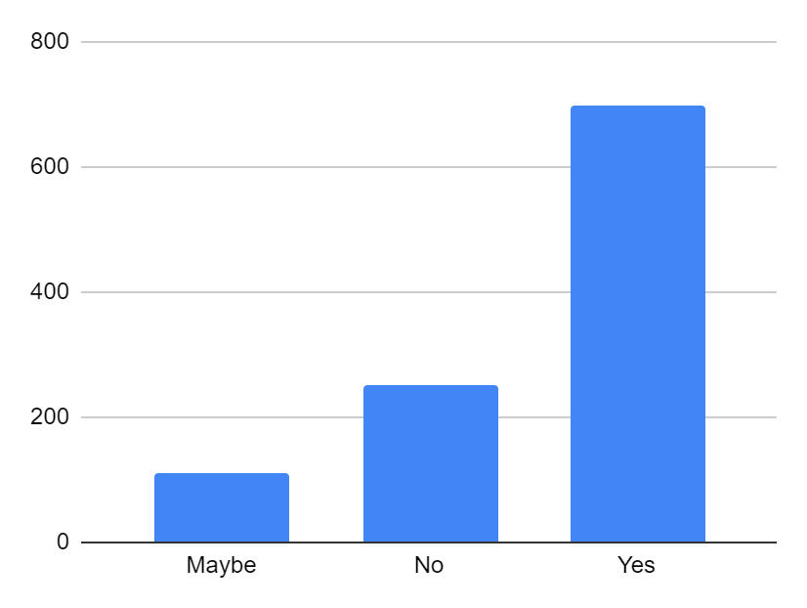

Fig 1.5

According to the study, 39.6% of students find online practical useful, 1.9% strongly agree that online practical is useful 28.3% of people are neutral about this, whereas 17.9% of people disagree with the efficiency of online practical, and 12.3% of students strongly disagree with online practical.

6.6 Teacher-student interaction:

Out of 1060 respondents, only 260 students (24.5%) hear regularly from their teachers, and 9.4% of students do not hear anything from their teachers, 66% of students hear from their teachers occasionally.
Of 1060 students, 420 students (39.6%) get the required help, 33% of students do not get the req Figures, red help.
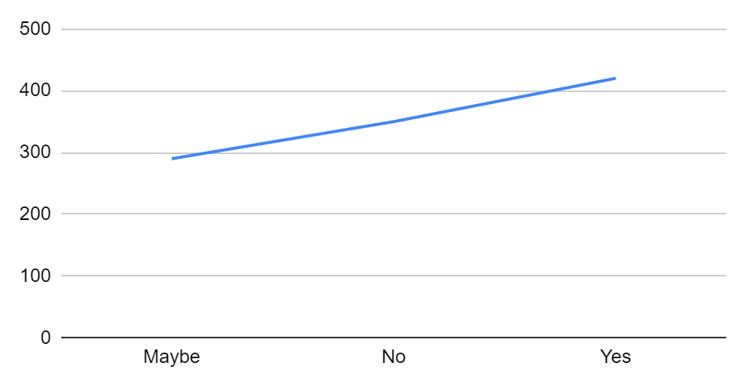
Fig 1.6

6.7 Technology:
46.2 % of students found it was moderate to learn new technology, 43.4% of students found it easy to learn new technology, and only 10.4 % of students found it difficult to learn new technology.

6.8 Focus:

Only 12.3% of students can focus very keenly on their work, and 6.6 % of students are completely unable to focus on their work. Maximum students (47.2%) are sometimes able to focus on their work keenly.
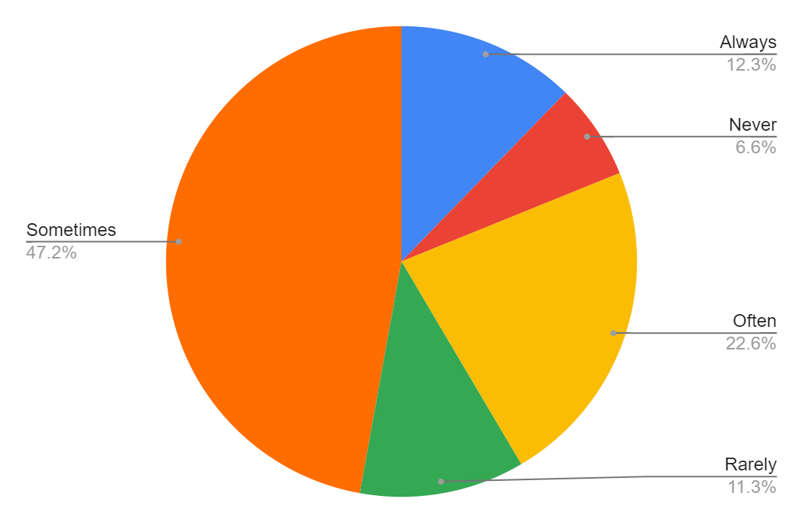
Fig 1.7

6.9 Internet Connectivity:

38.7 % of students find it sometimes easy to get internet connectivity, 34 % of students find it sometimes difficult to get an internet connection, 24.5% of students find it always easy to connect to the internet, and only 3.8% of students find it extremely difficult to get a proper internet connection.

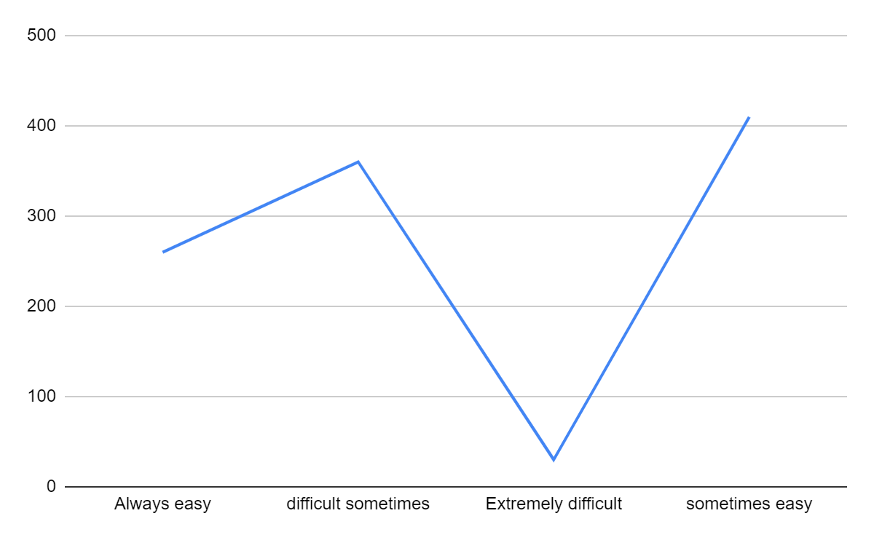
Fig 1.8

6.10 Exam:

48.1% of students think that online exams are conducive to cheating, 19.8% do not think this whereas 32.1% of people have no fixed opinion about this.

6.11 Area of living:

Out of 1060 students, 580 students, i.e. 54.7% students live in rural areas and 45.3% students live in urban areas.

RESULTS FROM TEACHER'S SURVEY:
This survey was also conducted using google forms.
A total of 180 teachers from different universities participated in the survey. The questions and the responses are as follows

Fig 1.
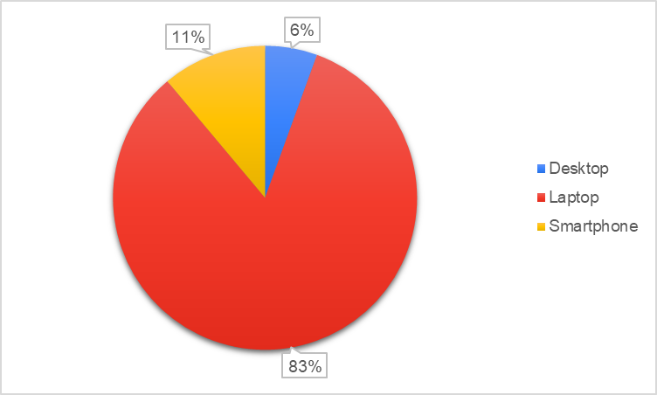

Fig 2.
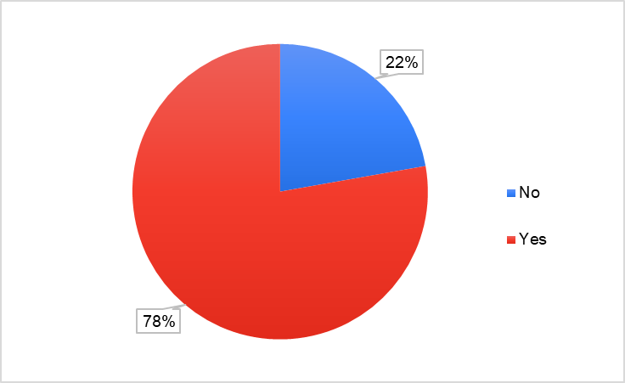

As shown in, life homework-life figures 1&2, most teachers nowadays are equipped with high-speed internet and laptops for conducting online classes and have adapted themselves as the need of the hour.
Fig 3.
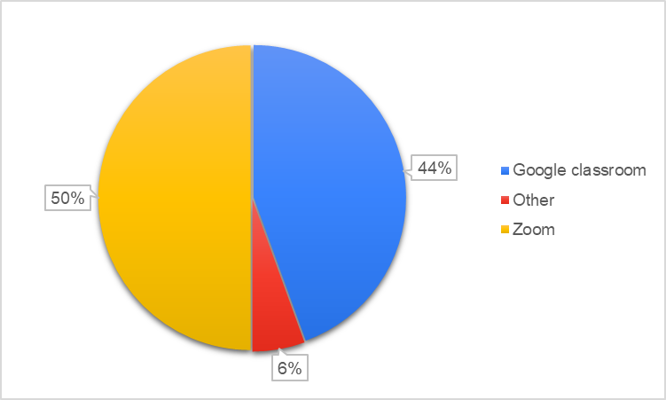
Most colleges were seen to be using zoom as their main application for online classes as compared to google classrooms, Microsoft teams, others suffer etc.
Fig 4.
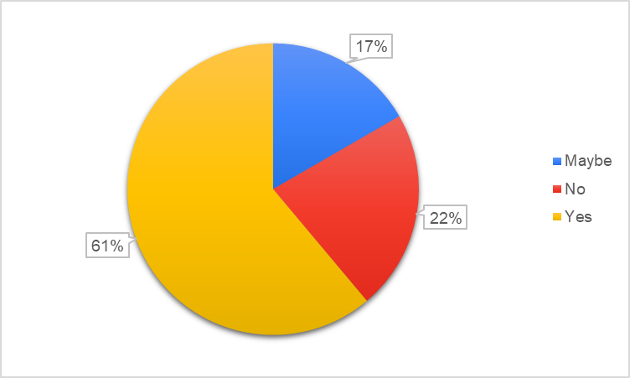
The maximum number of teachers was okay with zoom being the mode of communication. But there were around 20% of teachers who were dissatisfied.
Fig 5.
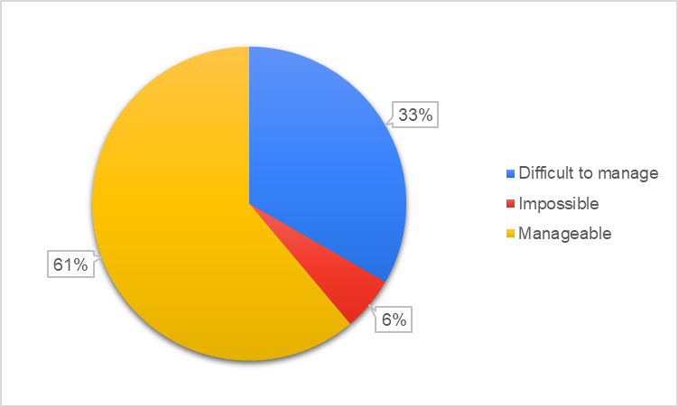
Out of all the teachers we surveyed, 60% got accustomed to the stress this pandemic has offered; 30% were finding it difficult to cope up with.
Fig 6.
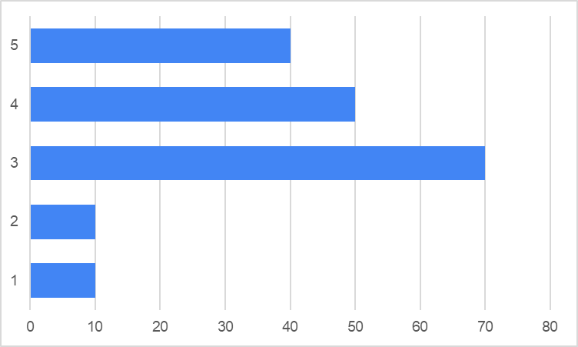
Out of 180 teachers, only 70 were able to balance their work-life balance extremely well and others were doing okay too.
Fig 7.
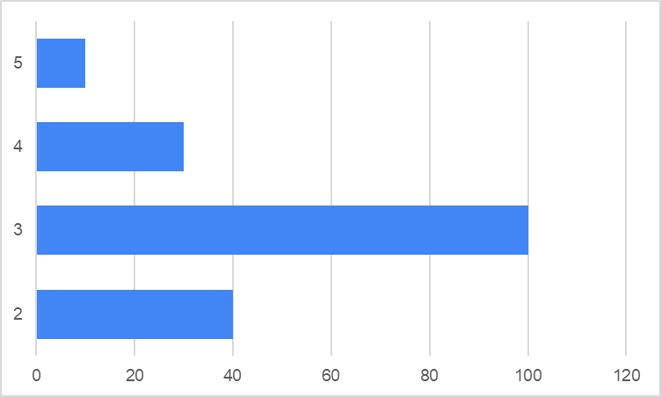
It was students, who found it difficult to cope up with the stress as observed by the teachers.
Fig 8.
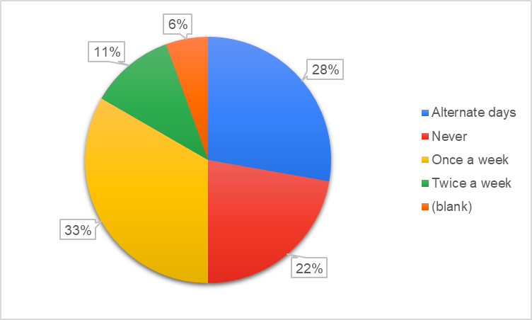
Teaching from home, balancing various responsibilities simultaneously, the teacher-student connection was somewhere lost. But some teachers (here 33%) still managed to interact with students at least once a week.
Fig 9.
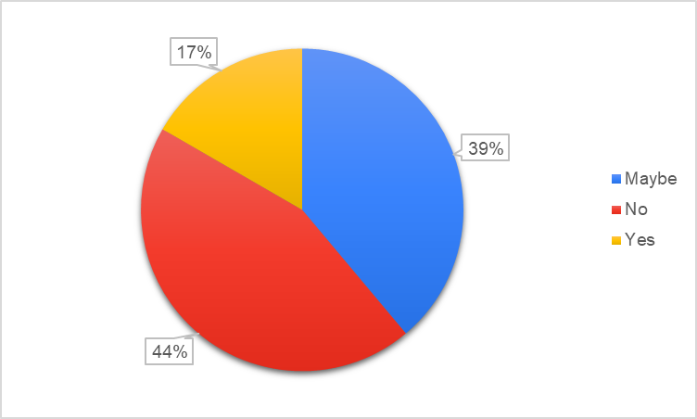
While 39% of teachers were unsure if students were learning as much as they did in offline mode; the majority of teachers said no.
Fig 10.
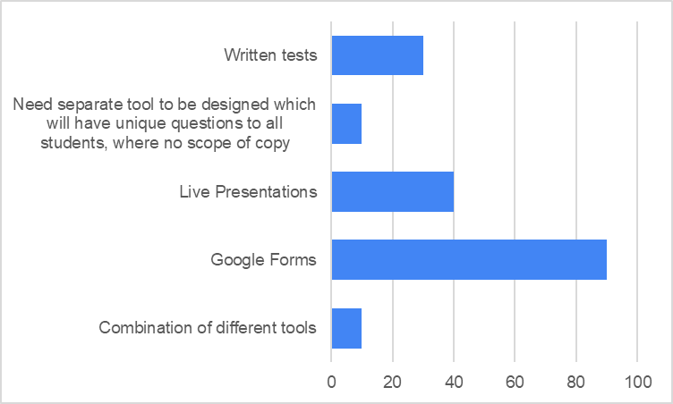
Google forms being more user-friendly, were used immensely to assess students online in comparison to written tests, live presentations, etc.
Fig 11.
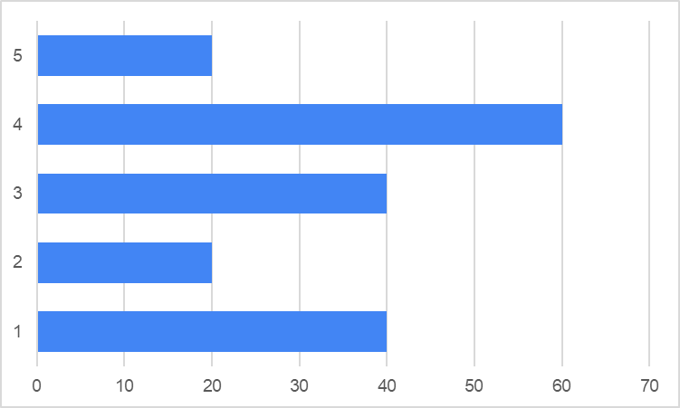
60/180 teachers were okay with the effectiveness of the online assessment process. However, 40 teachers were slightly unhappy as it is prone to cheating.
Fig 12.
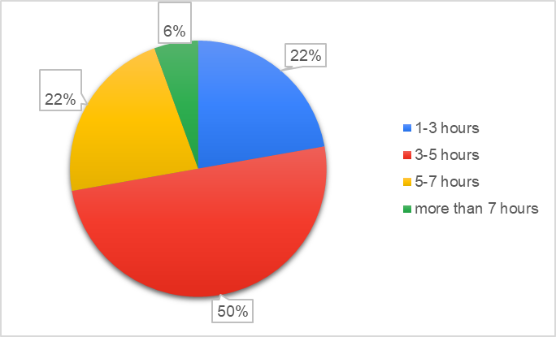
Usually, the college duration is found to be around 7-8 hours offline; but it was only around 3-5 hours for 50% of the teachers
Fig 13.
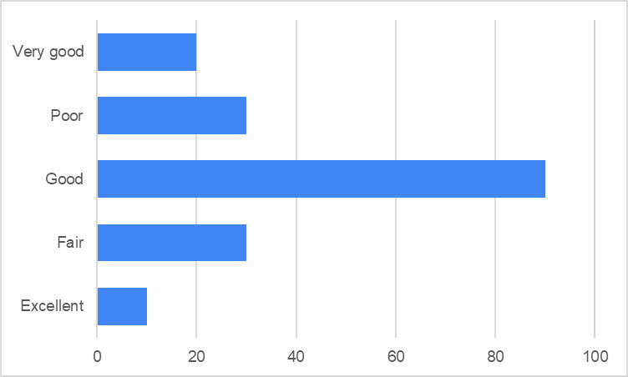
As can be seen here, the majority of teachers feel good about the overall online education.

CONCLUSION:
According to the responses we have received, the majority of students are from the computer science branch and the least students are from the civil department.
Almost all the students use laptops or phones for their online classes.
The average time students spend on online classes is about 3 to 5 hours a day.
Very few students are rarely eager to participate in online classes and the majority of them are often eager to participate.
From the survey, most students feel screen sharing is the best way to conduct the online practical and most of them also have all the software required for practical, and the rest of the students from civil and mechanical departments find it difficult to have the software.
Students find animations and PowerPoint presentations are the best approaches that can motivate them during online classes.
Most of the students occasionally hear from their teachers and very few students never hear from their teachers during the course of online learning and students are also getting the proper help with their work.
It is moderate for the students to use online learning and most of them are so focused on activities in their classes that they lose track of time.
The majority of students find it sometimes easy to connect to the internet and very few students generally from rural areas find it extremely difficult to connect to the internet for their online classes.
According to students their family members or neighbors occasionally disturb them and very few students have other responsibilities at their home other than studying.
Students feel that online learning is more conducive to cheating.
Looking at these results we can see that many students who face the problem of net issues are from rural areas. We can also say that the students who cannot focus or lack interest in online studies can be from rural areas and this is merely due to the lack of internet and proper technicalities. Also, the students who find that online practical are not useful are from Mechanical, Civil, and other departments. The maximum students from Computer Engineering, Electronics and Telecommunication departments think that online practical is useful. We can say that the overall response and effectiveness of online learning are interlinked between various aspects.
Both students and teachers agreed to the fact that the connection between them was somewhere lost. Most students and teachers agreed to the fact that online assessment is conducive to cheating but many teachers were happy about the online assessment. About 38% of students face difficulty in internet connection sometimes whereas 50% of teachers have a stable internet connection

ACKNOWLEDGEMENTS:
We offer our sincere thanks to the R&D wing of VIIT, Pune for allowing us to do a research internship under the guidance of Dr. Sachin R. Sakhare.

REFERENCES:

- Edwige S. The Impact of Online Teaching on Higher Education Faculty’s Professional Identity and the Role of Technology: The Coming of Age of the Virtual Teacher: written by Edwige Simon,2012.

- Shadnaz A, Jalena T, Mehran R, Wenlu Z, Roger CL, Antonella S. An observational study of engineering online education during the COVID-19 pandemic. April 15 2021, Journal Pone https://doi.org/10.1371/journal.pone.0250041

- Paul G, Ina B.Online Teaching Effectiveness: A Tale of Two Instructors, International Review of Research in Open and Distance Learning Volume 10, Number 3.June 2009.

- Mohanty, A. and Dash, D. (2016) Engineering Education in India: Preparation of Professional Engineering Educators. Journal of Human Resource and Sustainability Studies, 4, 92-101.http://dx.doi.org/10.4236/jhrss.2016.42011

- Bączek, Michał MD; Zagańczyk-Bączek, Michalina MD; Szpringer, Monika MD, PhD; Jaroszyński, Andrzej MD, PhD; Wożakowska-Kapłon, Beata MD, PhD Students’ perception of online learning during the COVID-19 pandemic, Medicine: February 19, 2021 - Volume 100 - Issue 7 - p e24821 doi: 10.1097/MD.0000000000024821

- Mathivanan, S.K., Jayagopal, P., Ahmed, S. et al. Adoption of E-Learning during Lockdown in India. Int J Syst Assur Eng Manag (2021). https://doi.org/10.1007/s13198-021-01072-4

- Sun, A., & Chen, X. (2016). Online education and its effective practice: A research review. Journal of Information Technology Education: Research, 15, 157-190.

- Jena, Pravat. (2020). ONLINE LEARNING DURING LOCKDOWN PERIOD FOR COVID-19 IN INDIA.

- Dhawan S. Online Learning: A Panacea in the Time of COVID-19 Crisis. Journal of Educational Technology Systems. 2020;49(1):5-22. doi:10.1177/0047239520934018

- Darius, P.S.H., Gundabattini, E. & Solomon, D.G. A Survey on the Effectiveness of Online Teaching–Learning Methods for University and College Students. J. Inst. Eng. India Ser. B 102, 1325–1334 (2021). https://doi.org/10.1007/s40031-021- 00581-x

- Naik, G. L., Deshpande, M., Shivananda, D. C., Ajey, C. P., & Manjunath Patel, G. C. (2021). Online Teaching and Learning of Higher Education in India during COVID-19 Emergency Lockdown. Pedagogical Research, 6(1), em0090. https://doi.org/10.29333/pr/9665

- Bao, Wei, “COVID‐19 and online teaching in higher education: A case study of Peking University”, Human Behaviour and Emerging Technologies, 07 April 2020.

- Arkorful V, Nelly A, “The role of e-learning, advantages and disadvantages of its adoption in higher education”, International Journal of Education and Research, 12 December 2014.

- Eddie JA, Christopher WB, “A Comparison of Student Learning Outcomes in Traditional and Online Personal Finance Courses”, MERLOT Journal of Online Learning and Teaching, 4, December 2011.

- Lokanath M, Tushar G, Abha S, “Online teaching-learning in higher education during lockdown period of COVID-19 pandemic”, International Journal of Educational Research Open, 3 September 2020.

- Pinaki C, Prabhat M, Manu SG, Savita Y, “Opinion of students on online education during the COVID-19 pandemic”, Human Behaviour and Emerging Technologies, 17 December 2020.

- Souvik S, “Possibilities and Challenges of Online Education in India during the COVID-19 Pandemic”, International Journal of Web-Based Learning and Teaching Technologies.

- EDWIGE S, “The impact of online teaching on higher education faculty’s professor’s identity and the role of technology: The coming of age of the virtual teacher”, non-Journal, 2012.

- Amit J, Muddu V, Preeti B, “Impact of coronavirus pandemic on the Indian education sector: perspectives of teachers on online teaching and assessments.” Interactive Technology and Smart Education, 4 September 2020.

- Abinaya S, “Impact of Covid-19 on school education in India”, Readers’ blog, 25 May 2021.

- Elizabeth AM, Kim RM, Barbara Y, Shannon SB, “COVID-19 and Distance Learning: Effects on Georgia State University School of Public Health Students”, Front. Public Health, 25 September 2020.

